**DOCUMENTATION**

**ON**

**WEB APPLICATIONS**

**&**

**ANDROID APPLICATIONS**

**PLATFORMS:-**

**1.TUMBLR**

**2.REDDIT**

**3.PINTEREST**

**4.ZOMATO**

**5.VIBER**

**6.MESSENGER**

**7.CHINGARI**

**8.NAUKRI**

**TUMBLR**

**WEB APPLICATION**

**Tumbler is a microblogging and social networking website. Users can post multimedia and other content to a short-form blog. Not only this, but users can follow other users as well. So let’s see what the website contains:-**

**1.After opening the website it asks to get started by signing up, if already signed up then just login to the website.**

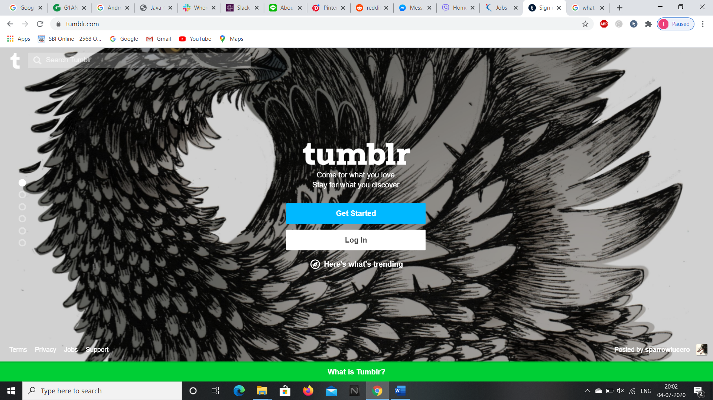

**2.During the signing up process, the website asks for E-mail, Password, Username and your Age.**

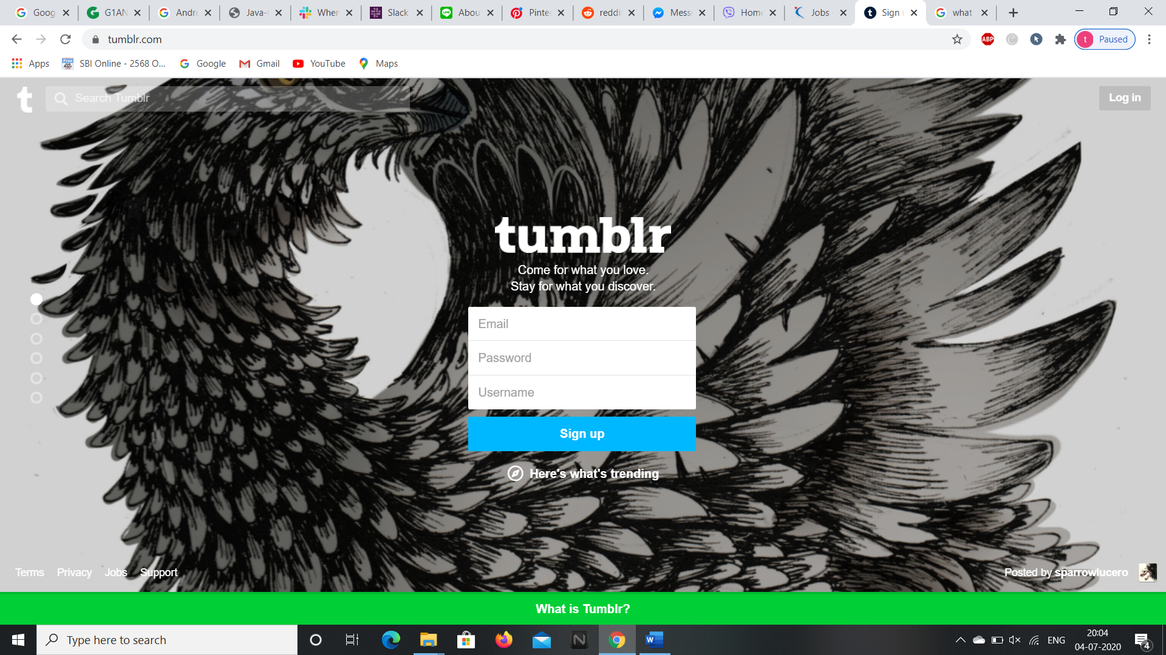

**3.After logging in or signing up we can access the home page.**

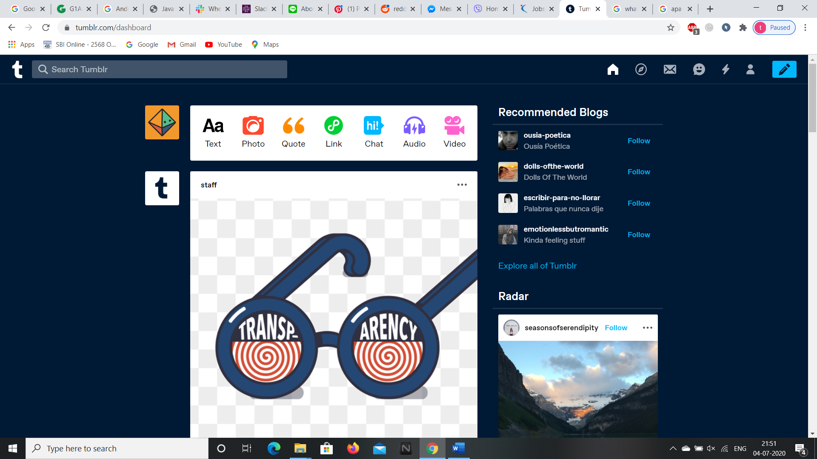

**4.We can check any new messages in the clicking on message icon at the top right corner of the page.**

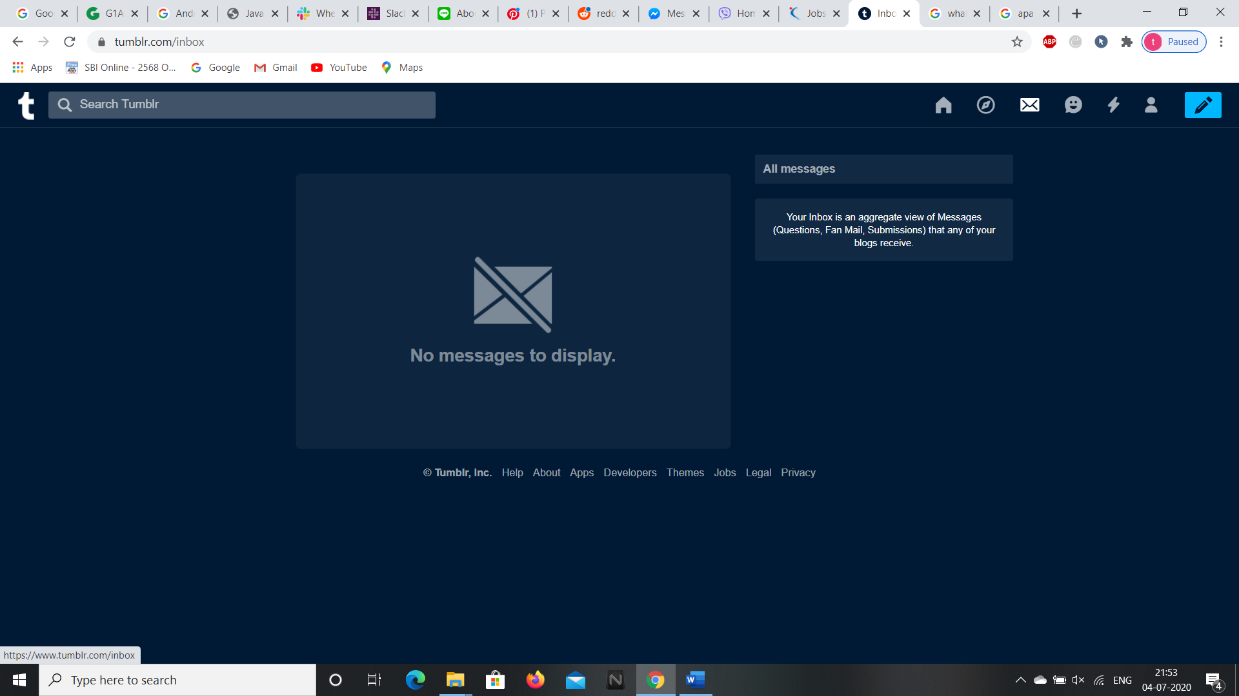

**5.We can check our messages and activities by clicking on the emoji icon on the top right corner.**

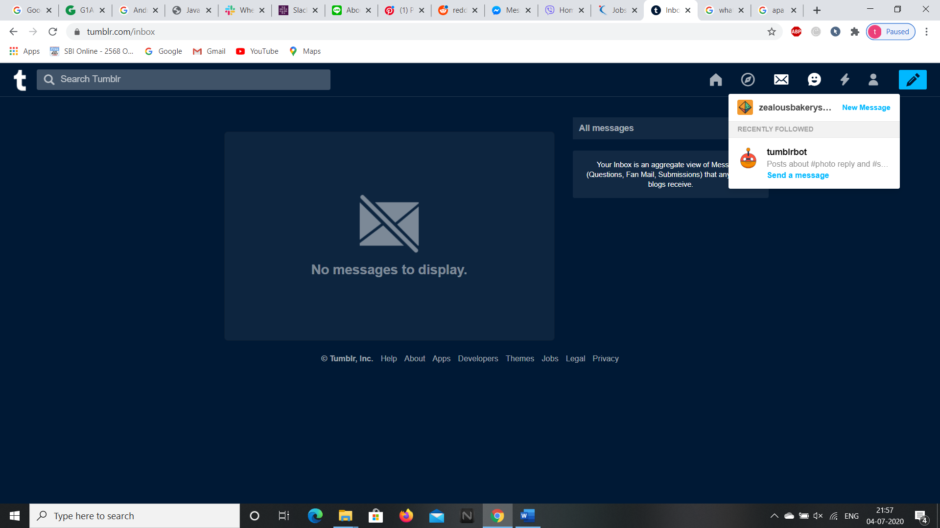

**6.We can check our new posts, likes, and new followers by clicking on the thunder symbol at the right corner of the page.**

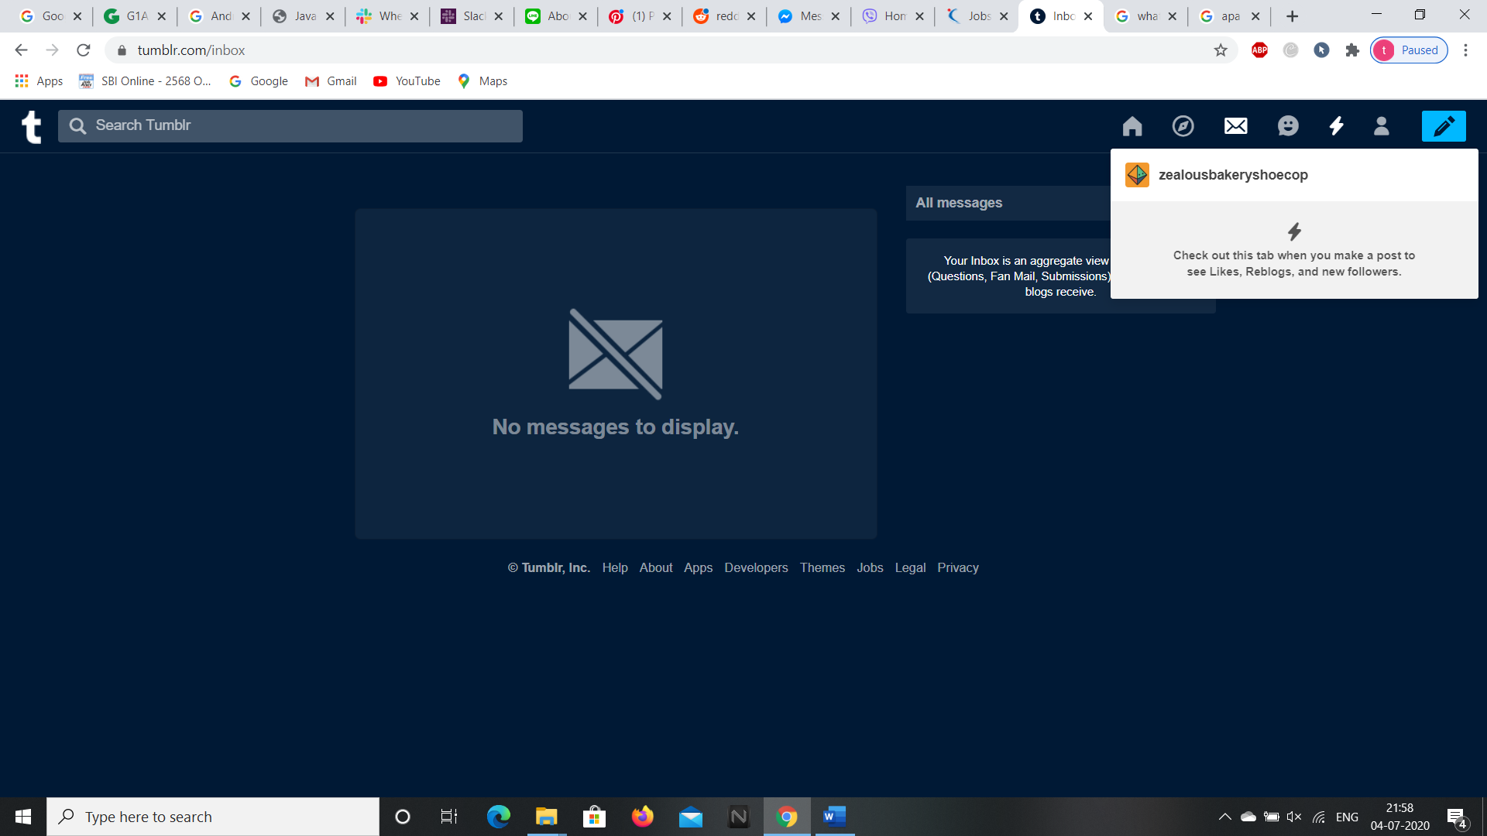

**7.We can check the details of our account by clicking on the people icon present at the right side of the thunder icon.**

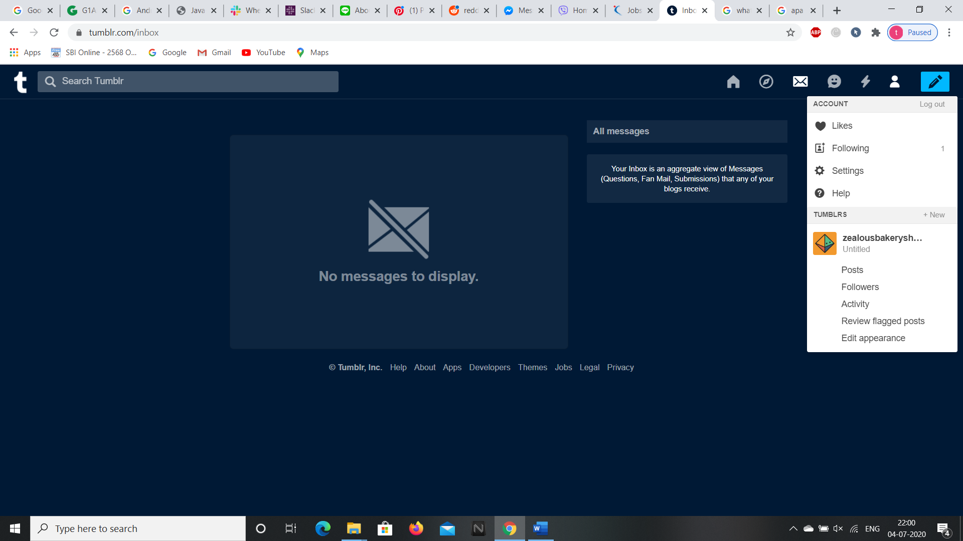

**8.We can create our new posts by clicking the edit icon at the top right corner of the page whether it may be text or video or audio and many.**

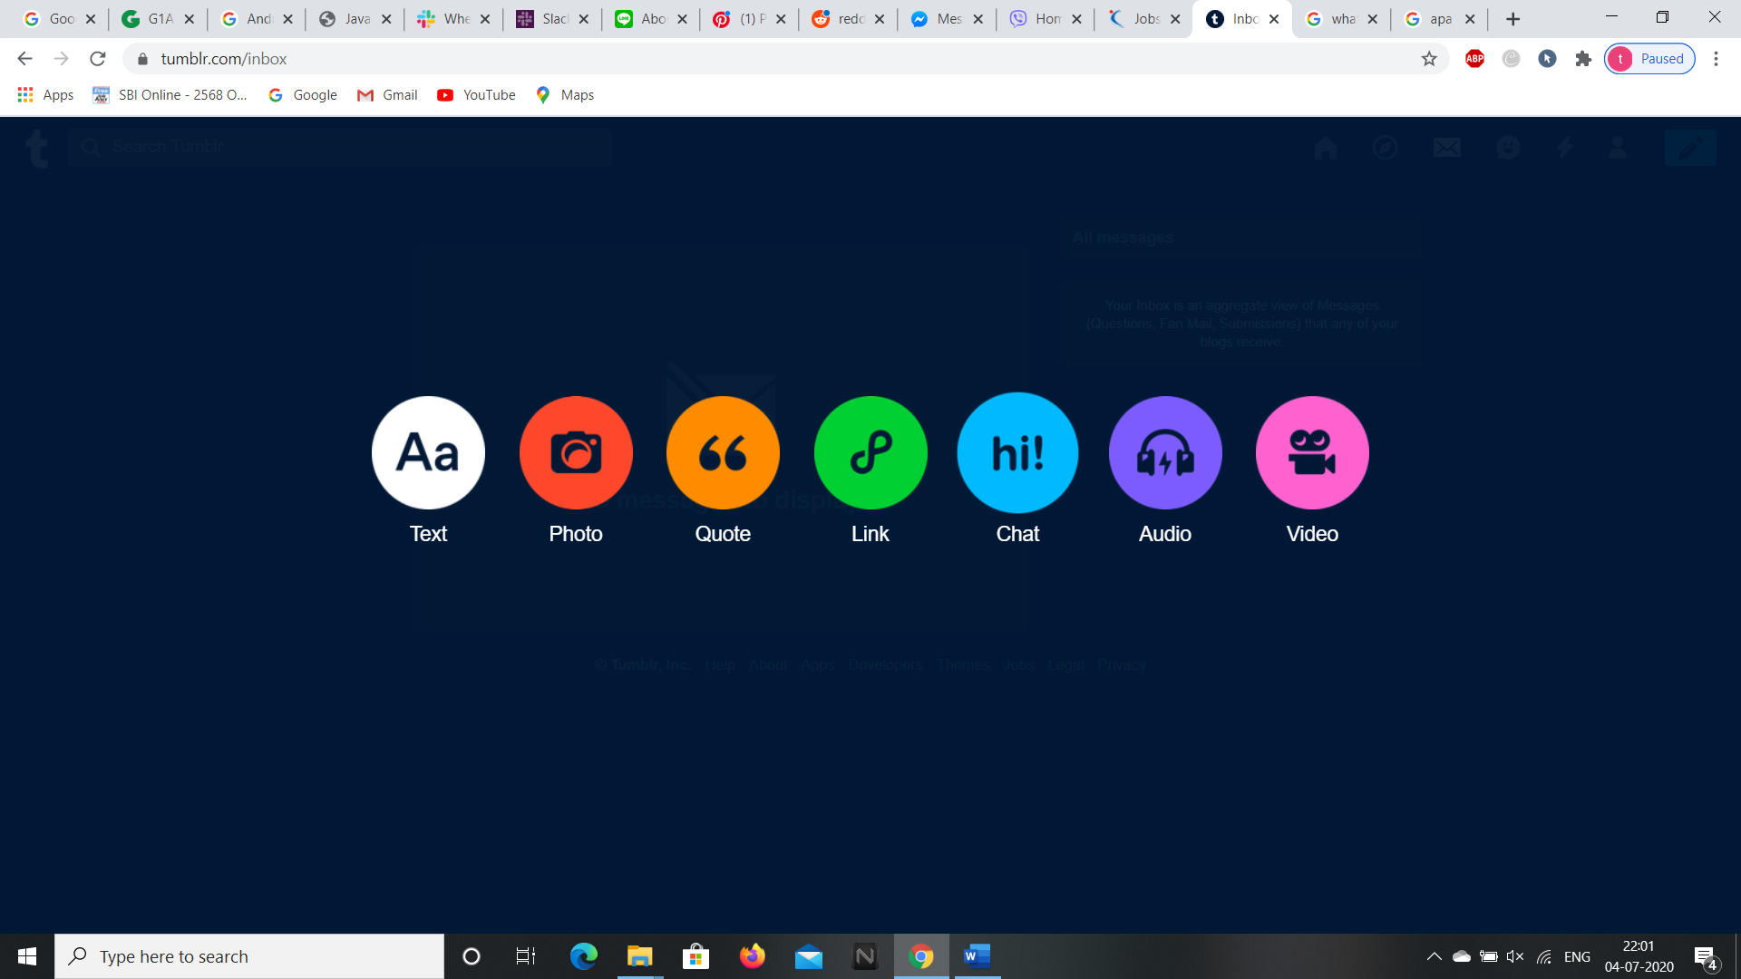

**We can access the trending posts by clicking the clock icon beside home icon or without signing in as well. Let’s see the trending posts without signing in**

**9.If we want to see the trending blogs then click on the “Here’s what’s trending” option or if we want to search a blog we can type the blog in the search box.**

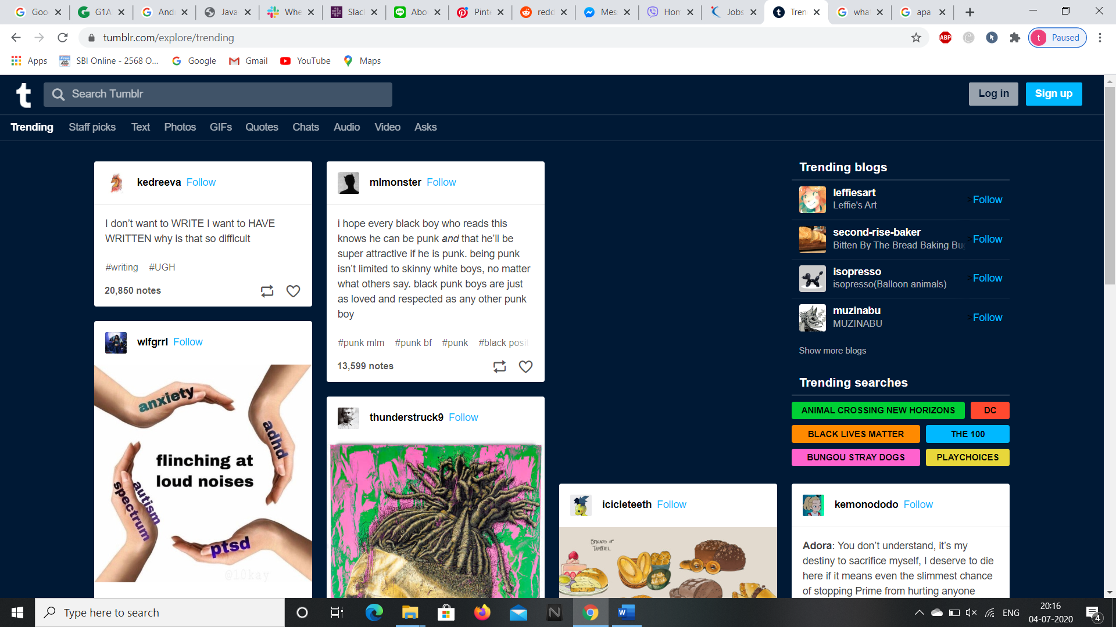

**10.By clicking on “Staff picks” the blogs picked mostly by staff will be opened.**

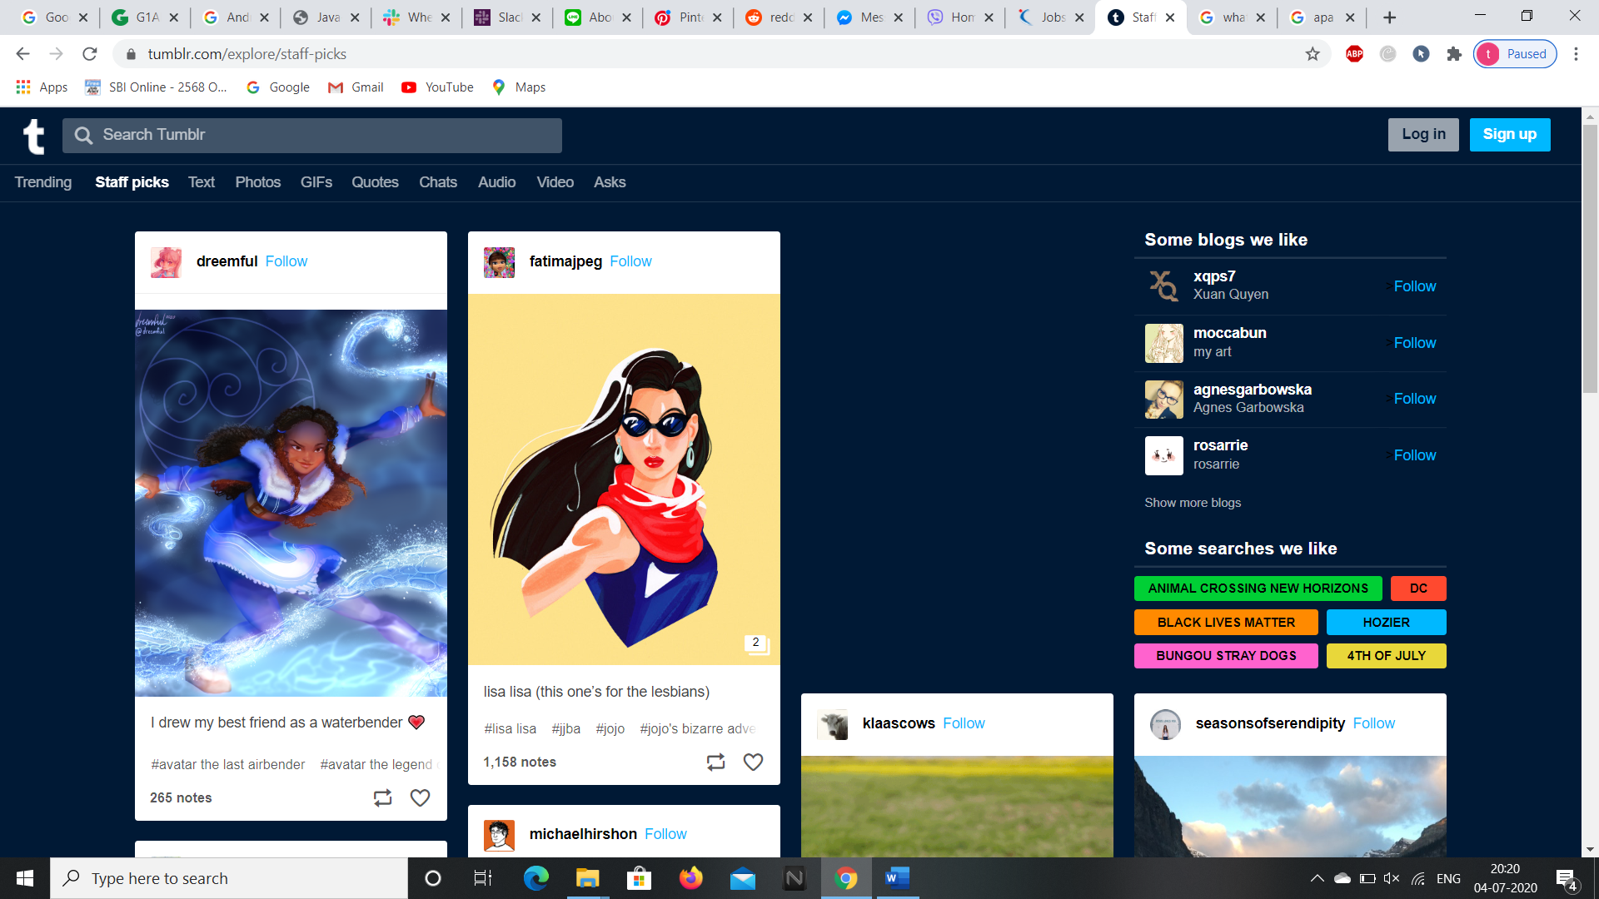

**11.To open the popular texts in the website click on “Text” in the webpage.**

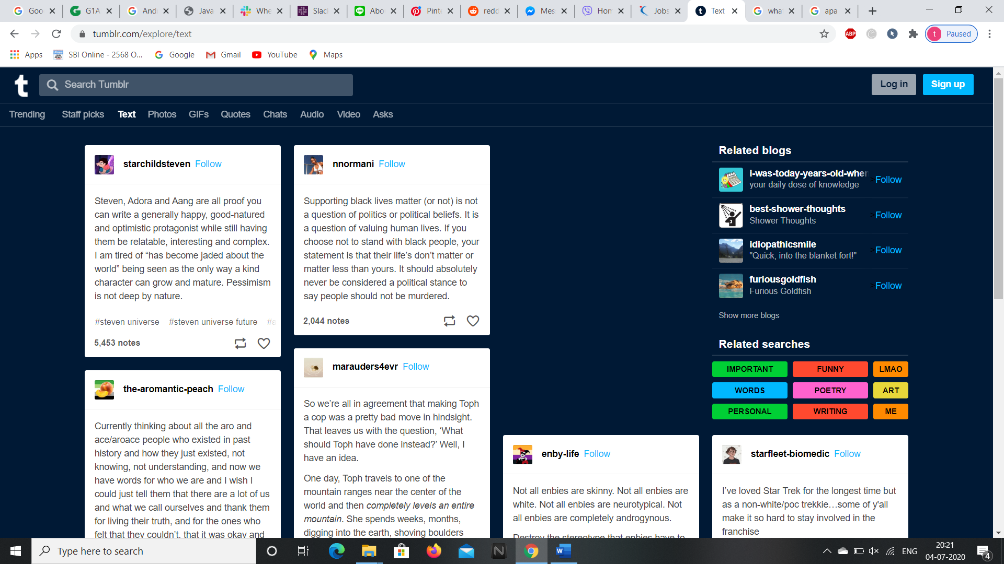

**12.To get the latest and trending photos click on “Photos” in the webpage.**

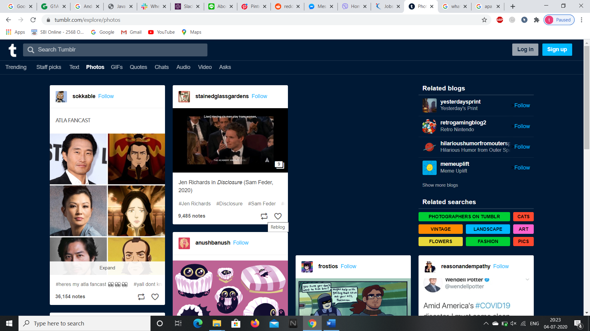

**13.To open the popular GIFs in the website click on “GIFs”.**

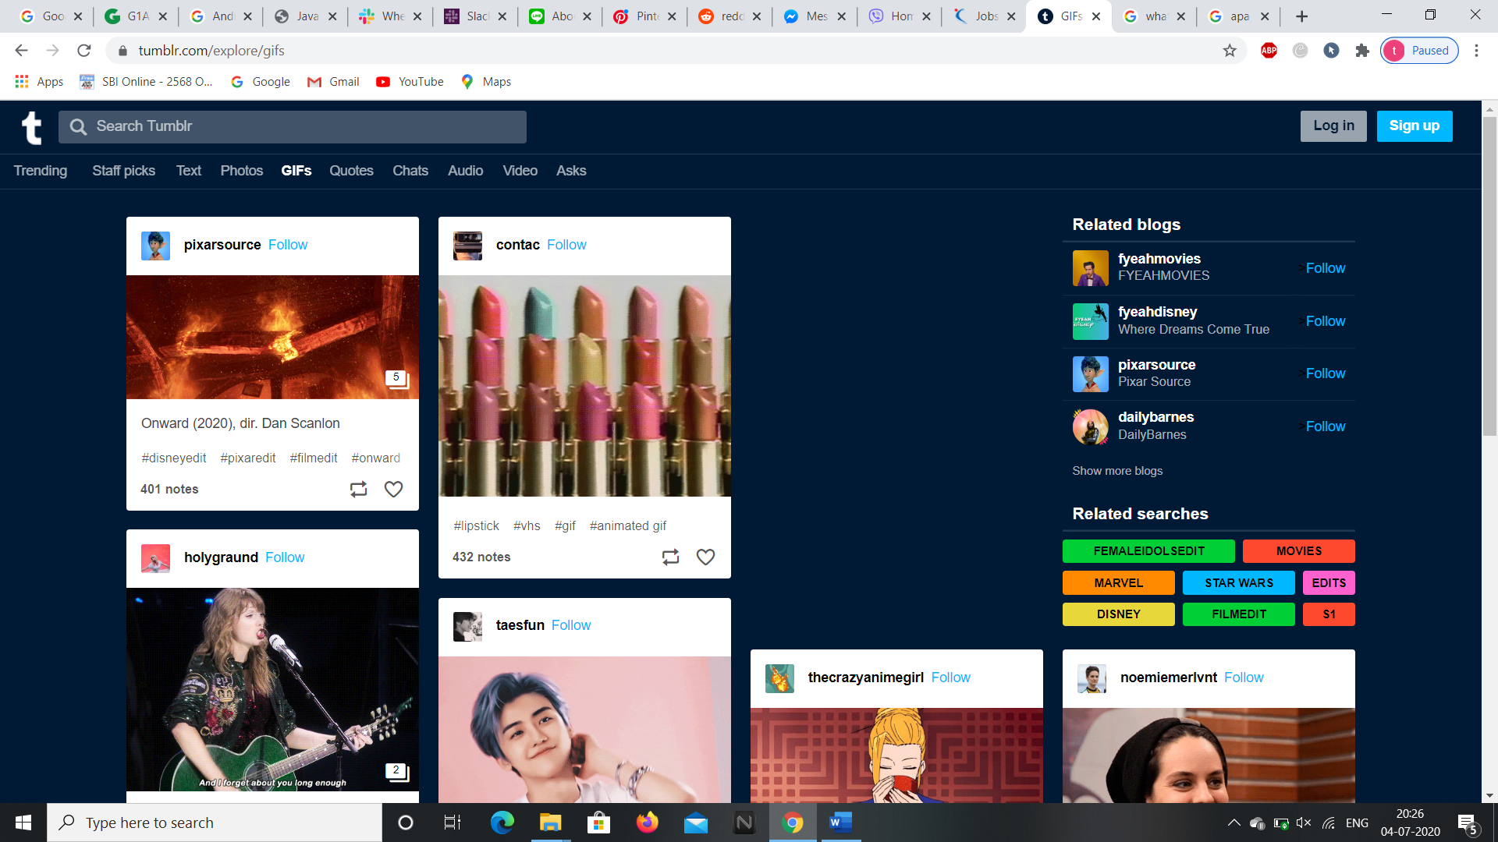

**14.To open the webpage on popular blogs go to “Quotes”.**

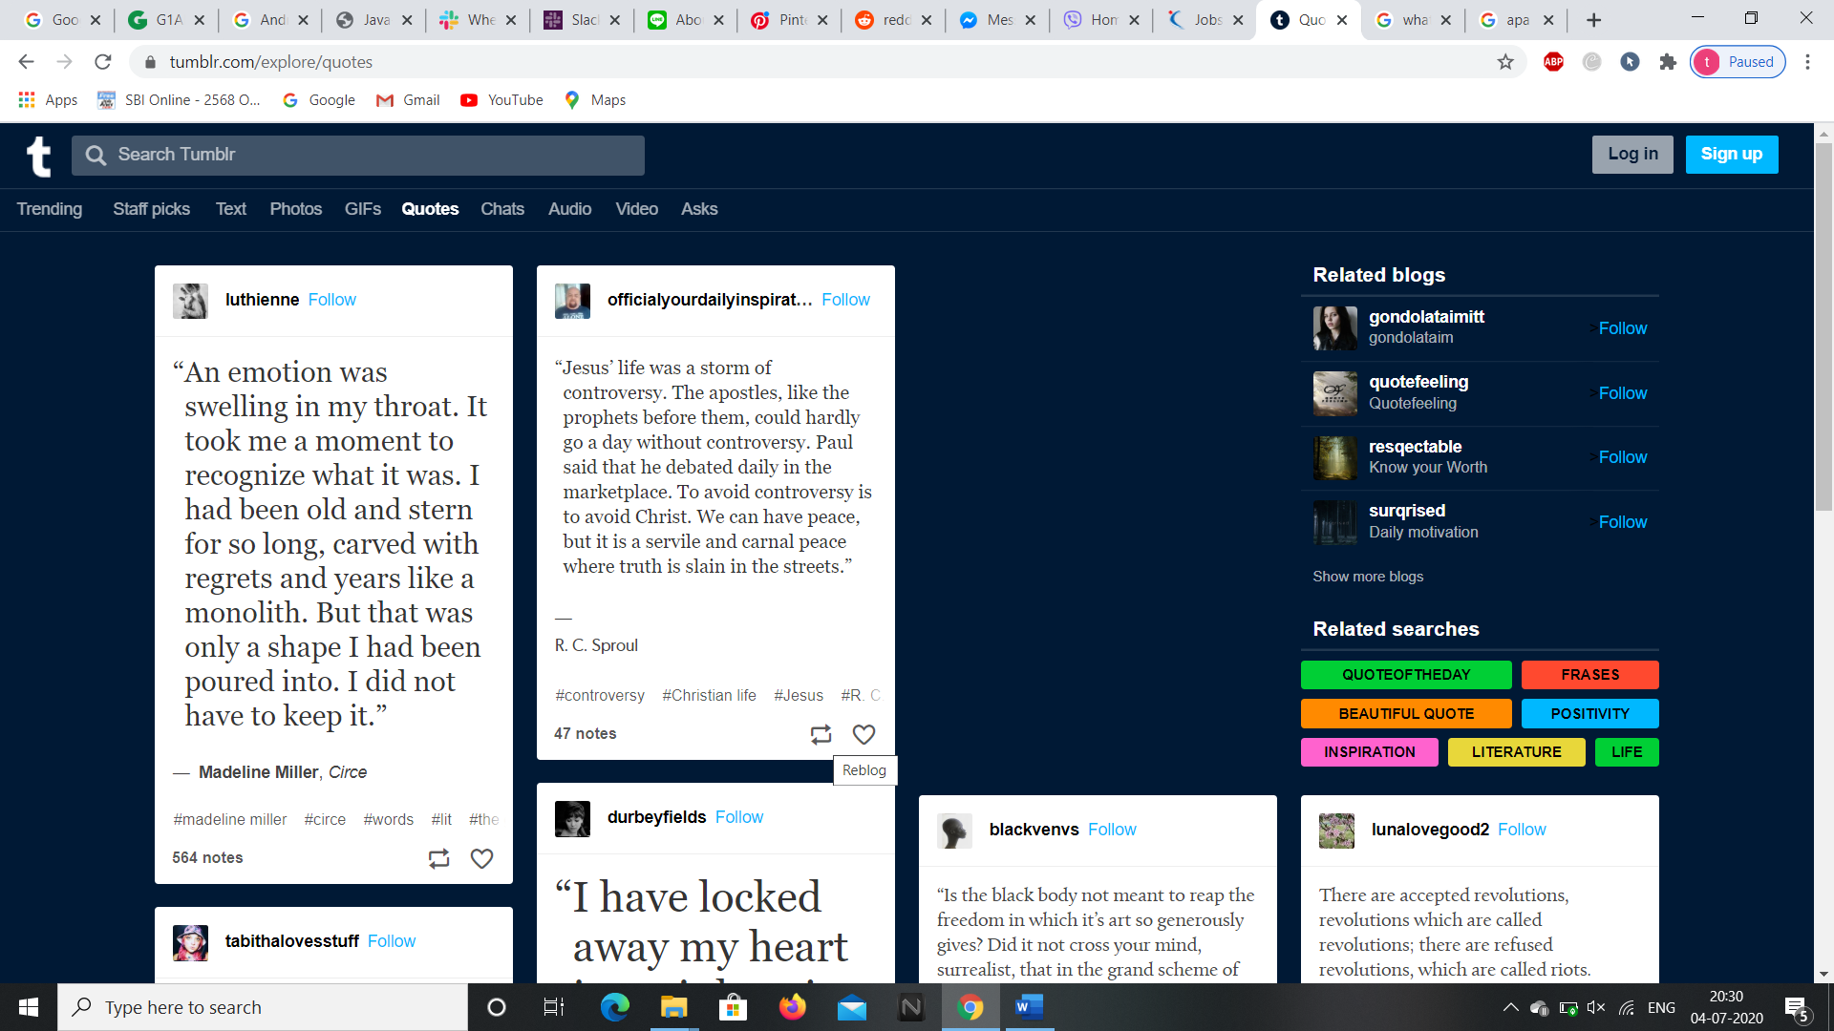

**15.To open recent and popular chats in the webpage go to “Chats”.**

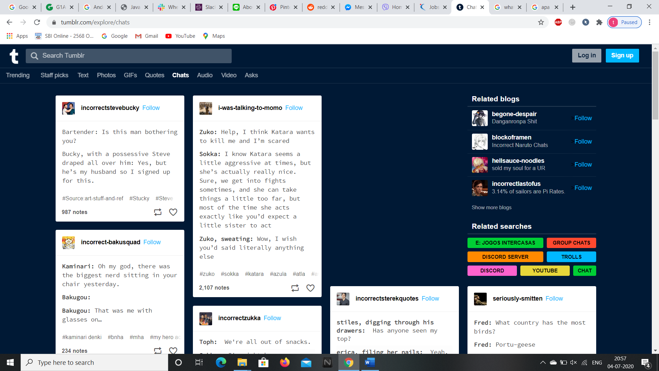

**16. To open recent and popular audio in the webpage go to “Audio”.**

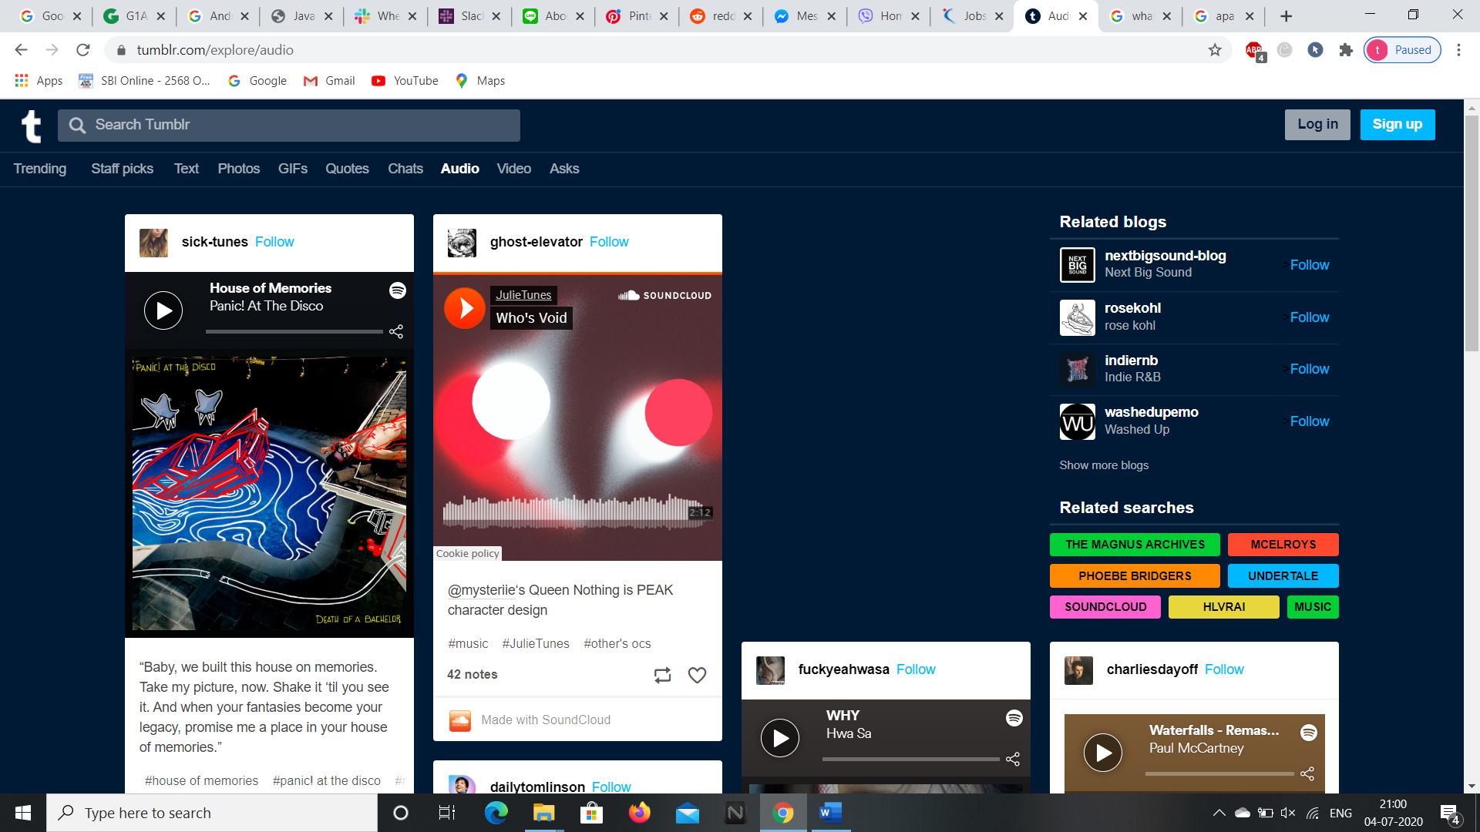

**18. To open recent and popular videos in the webpage go to “Video”.**

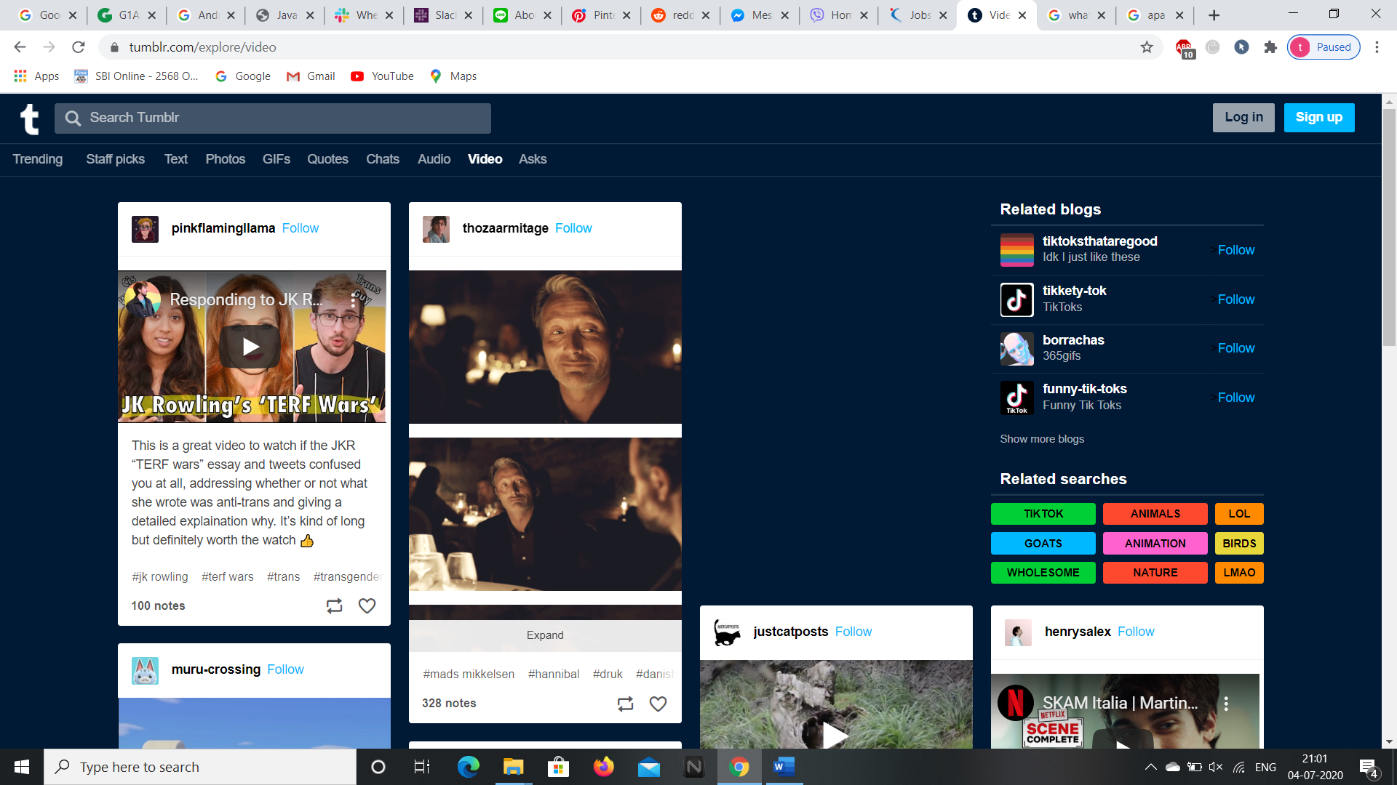

**19. To open recent and popular questions asked in the webpage go to “Asks”.**

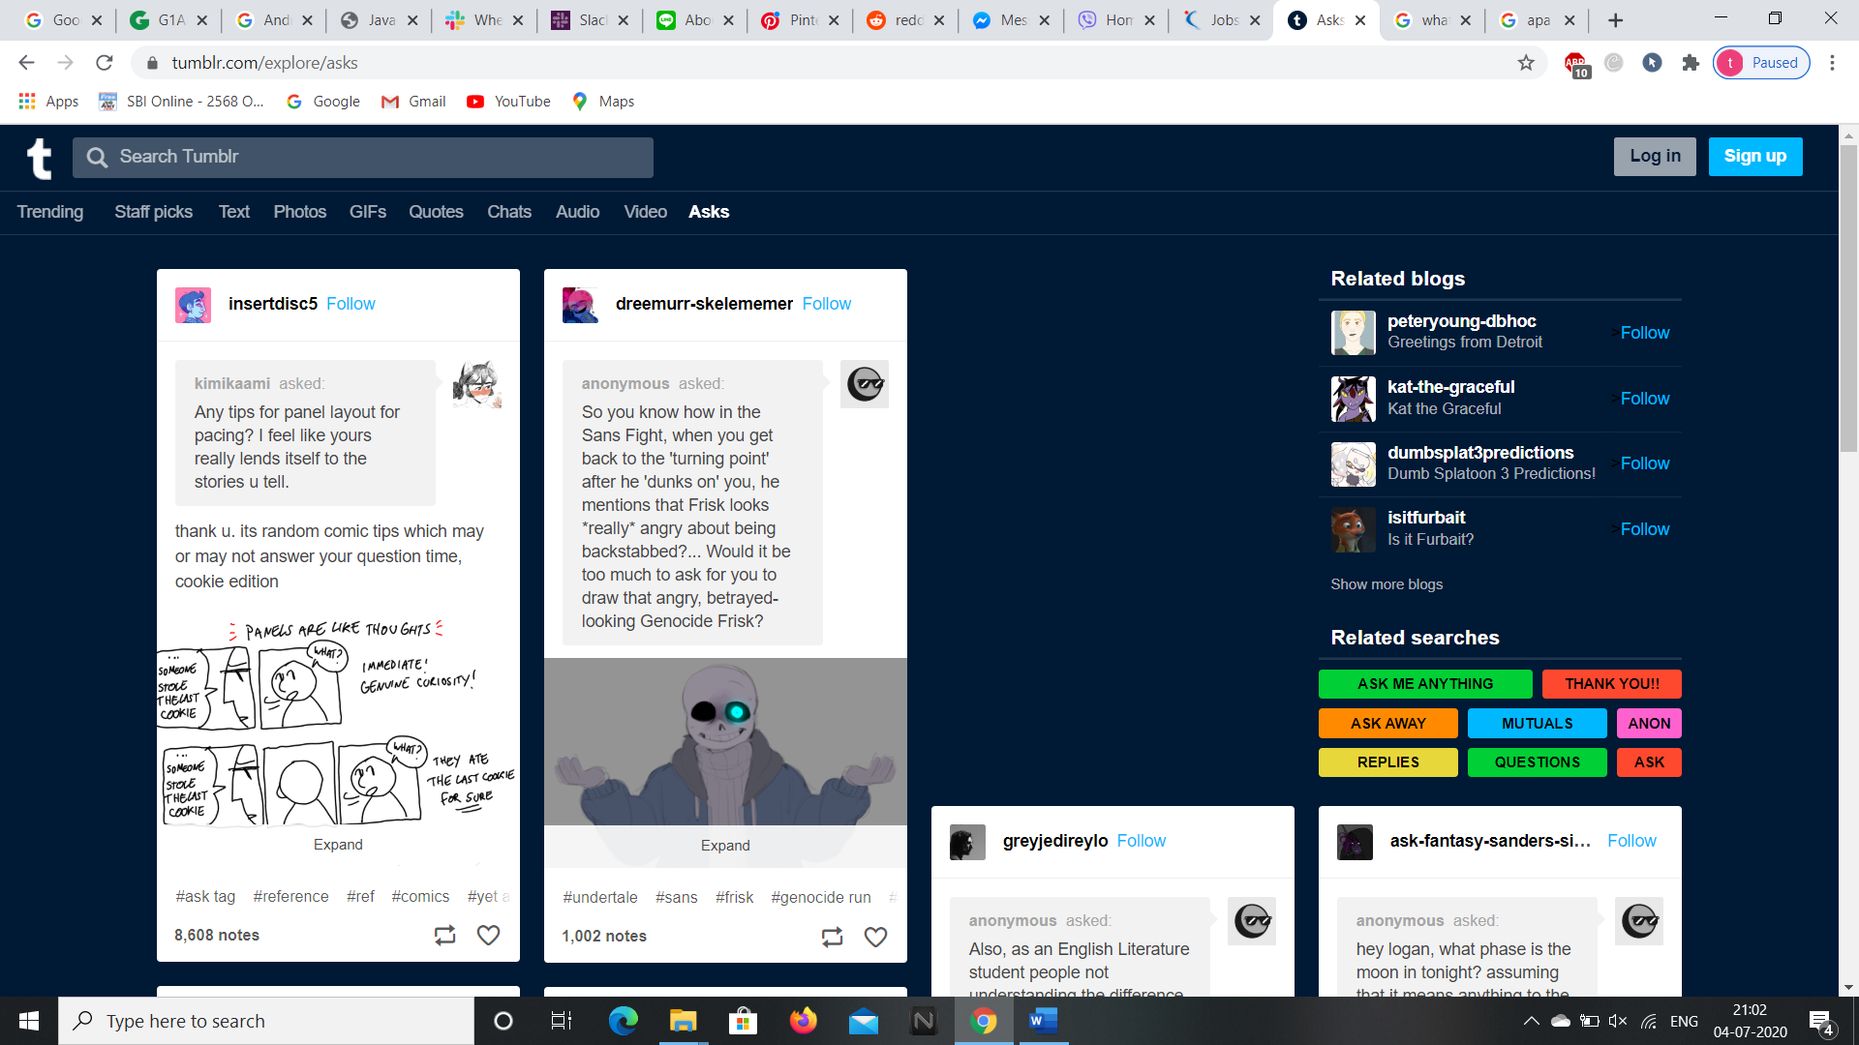

**20.To follow the blogs click on “Follow” at the top right corner of the blog.**

**21.We can also follow the blogs related to our search through “Related blogs”.**

**We can control the website by providing the element id or xpath to the Selenium addon in the G1ANT Studio. Let’s see the android application of it.**

**ANDROID APPLICATION**

**We can download the android application through “Google Play Store” and installing it in the Virtual Phone through Android Studio.**

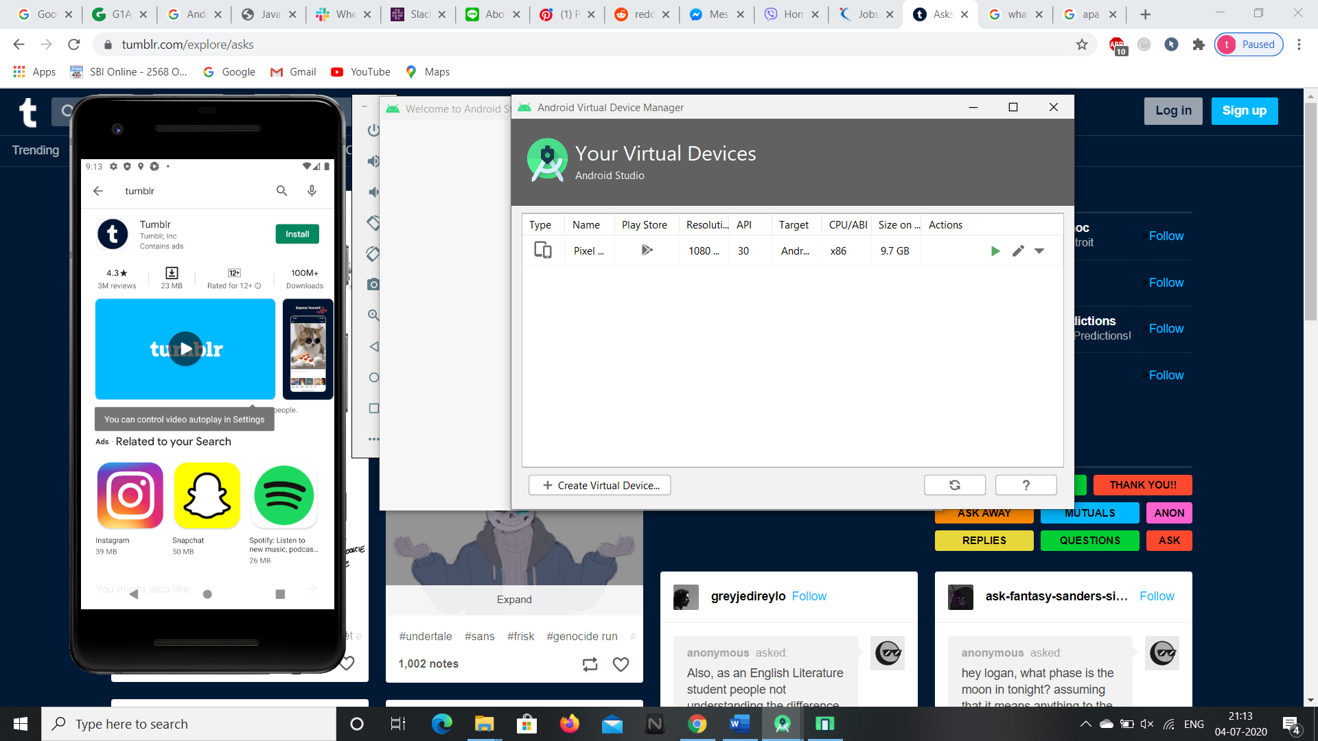

**1.After installing it open the app and it asks to sign up or login similar to**

**web application process and asks for further interests in the blogs .**

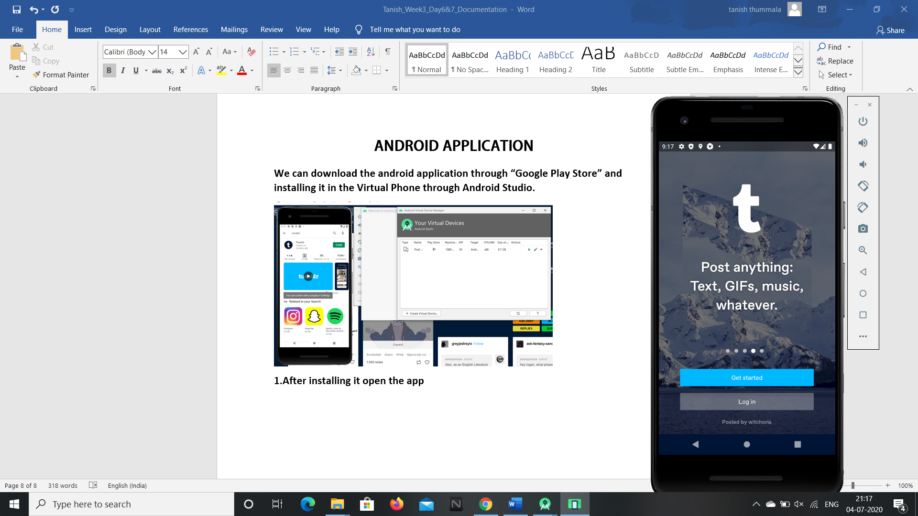 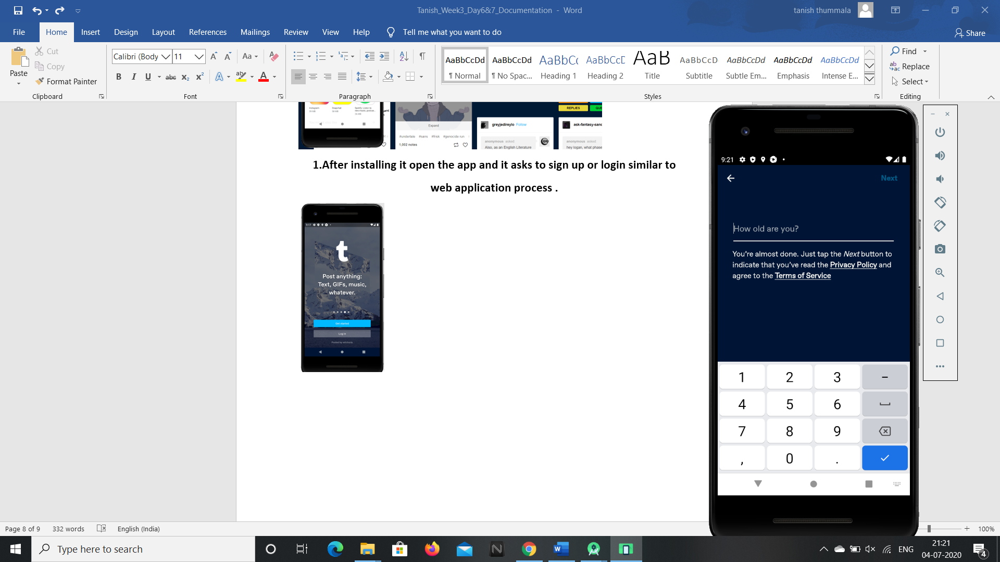 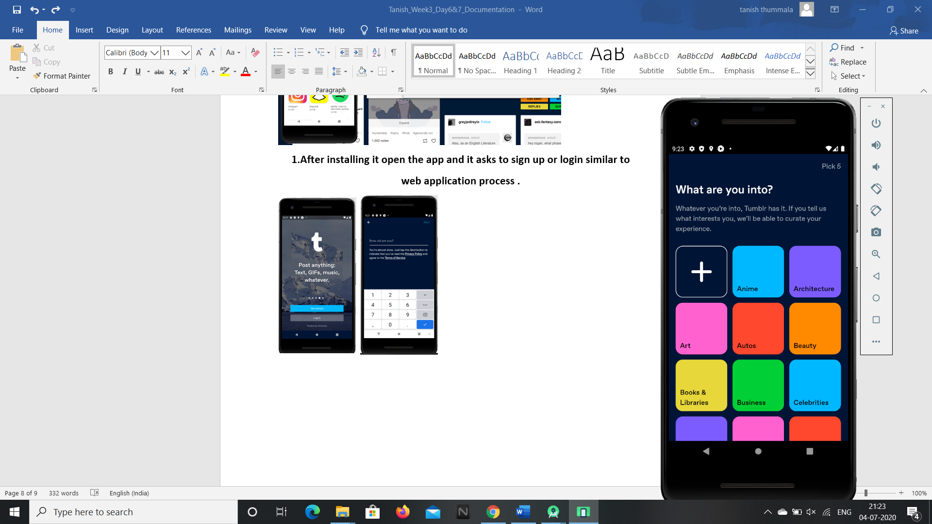 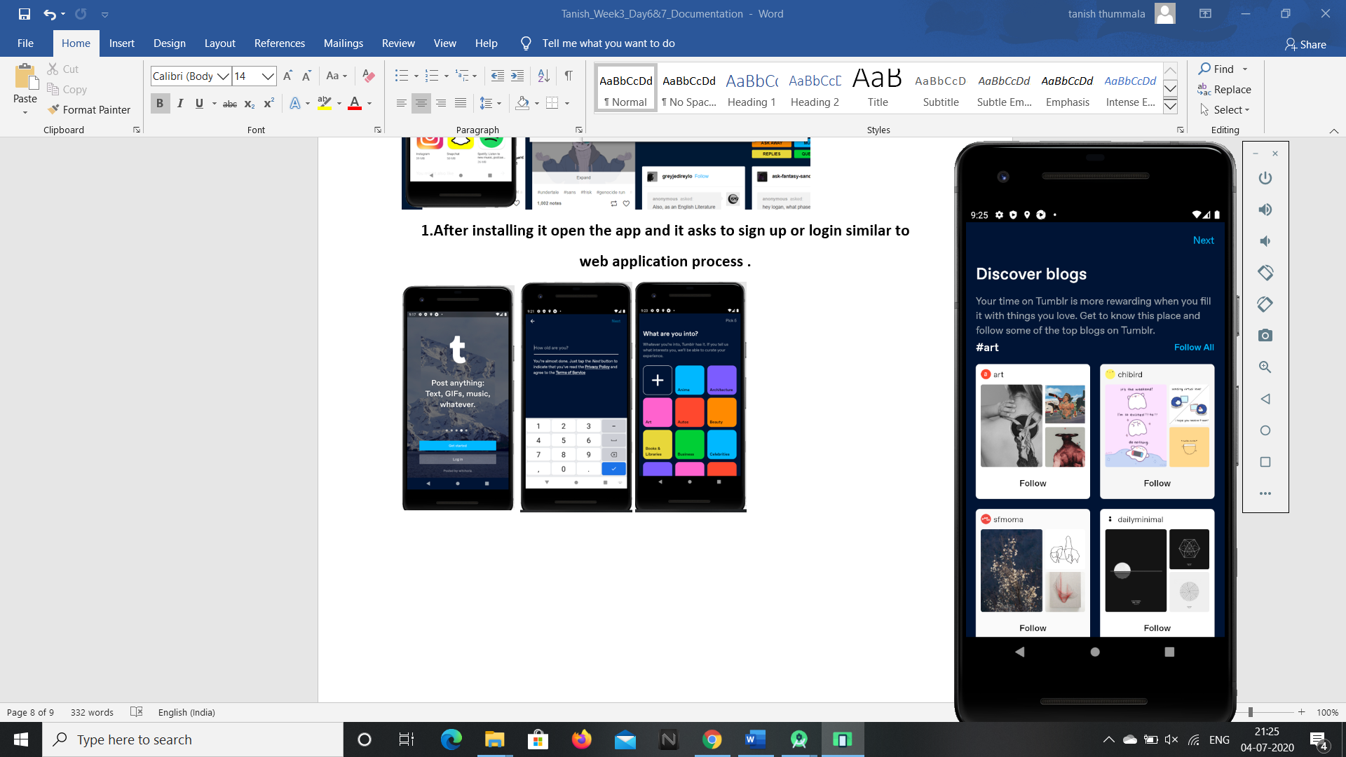

**2.It opens the tumblr home page in the android application.** 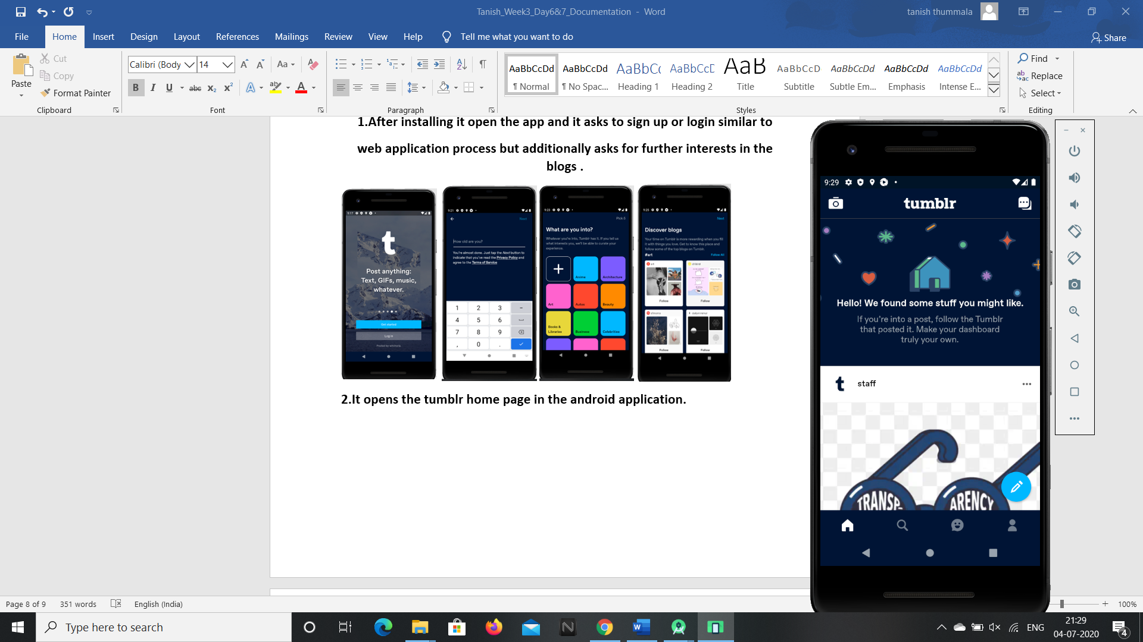

**3.To search the blogs click on the search icon in the home page.**

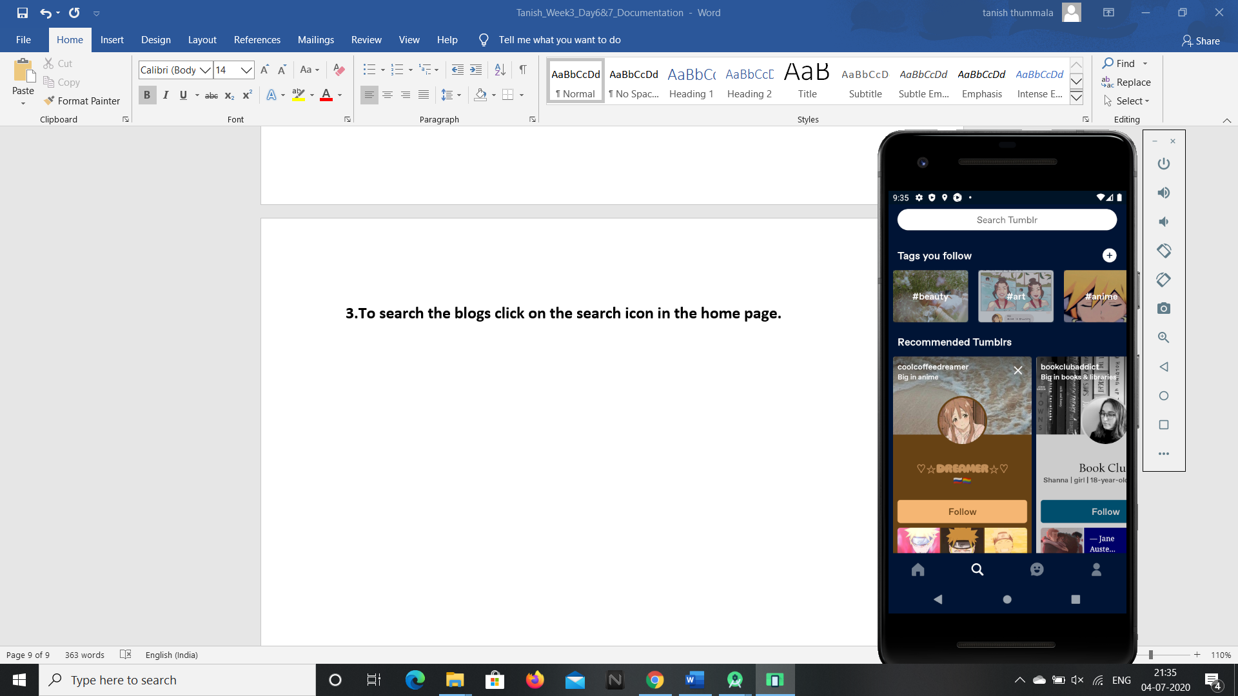

**4.To check your activity and messages click on the emoji icon.**

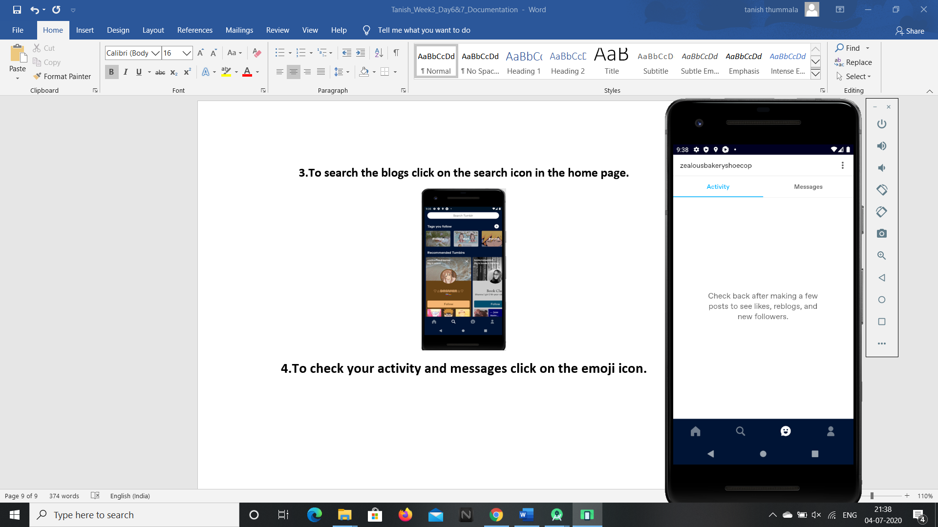 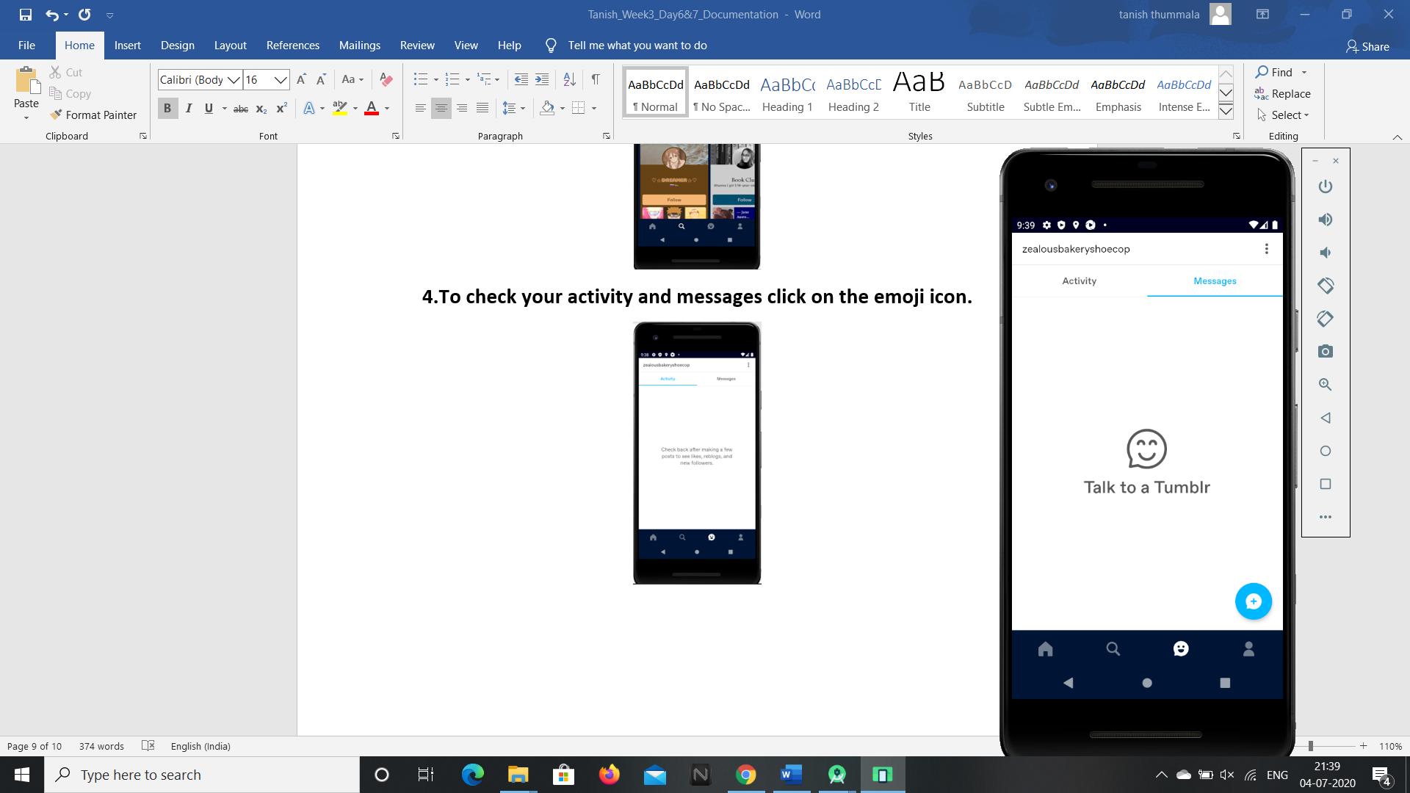

**5.To view your posts,likes and following click on the people icon.**

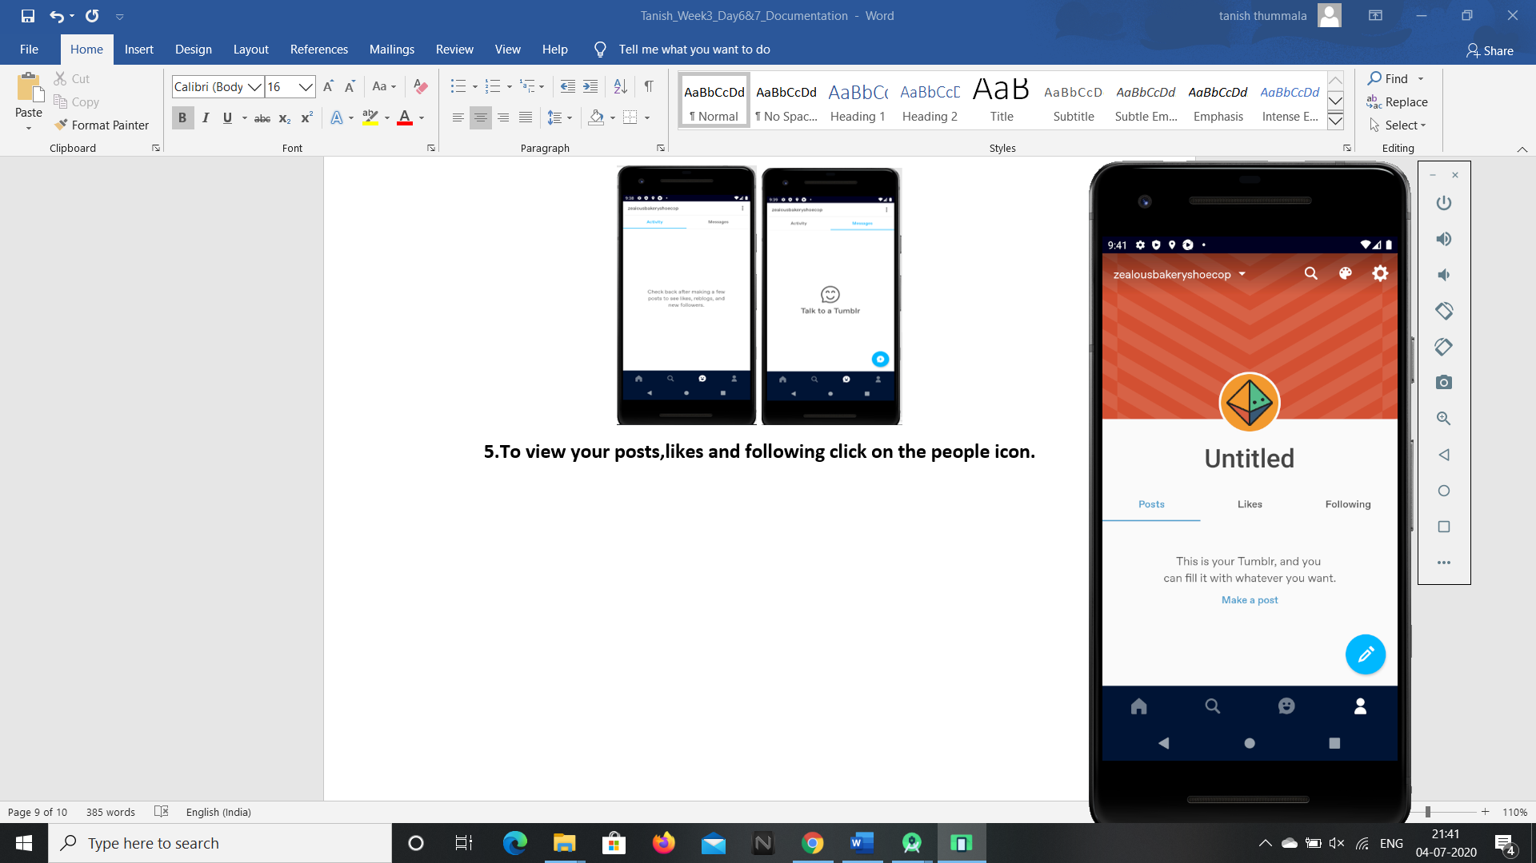 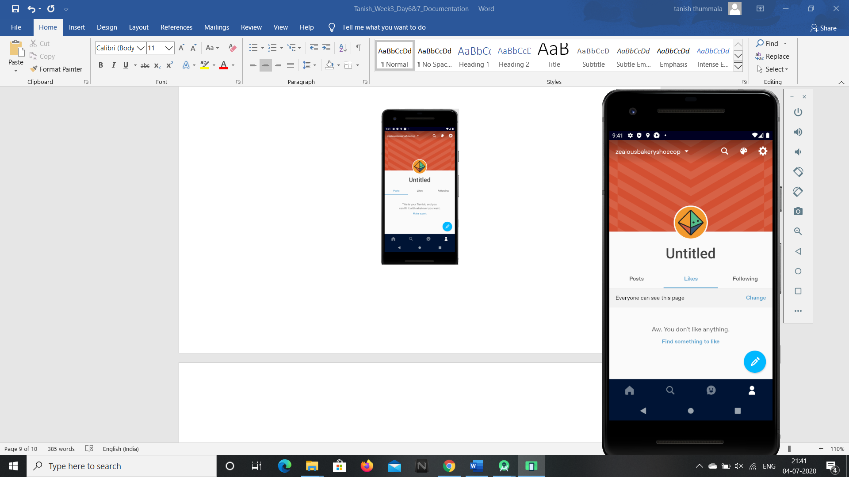 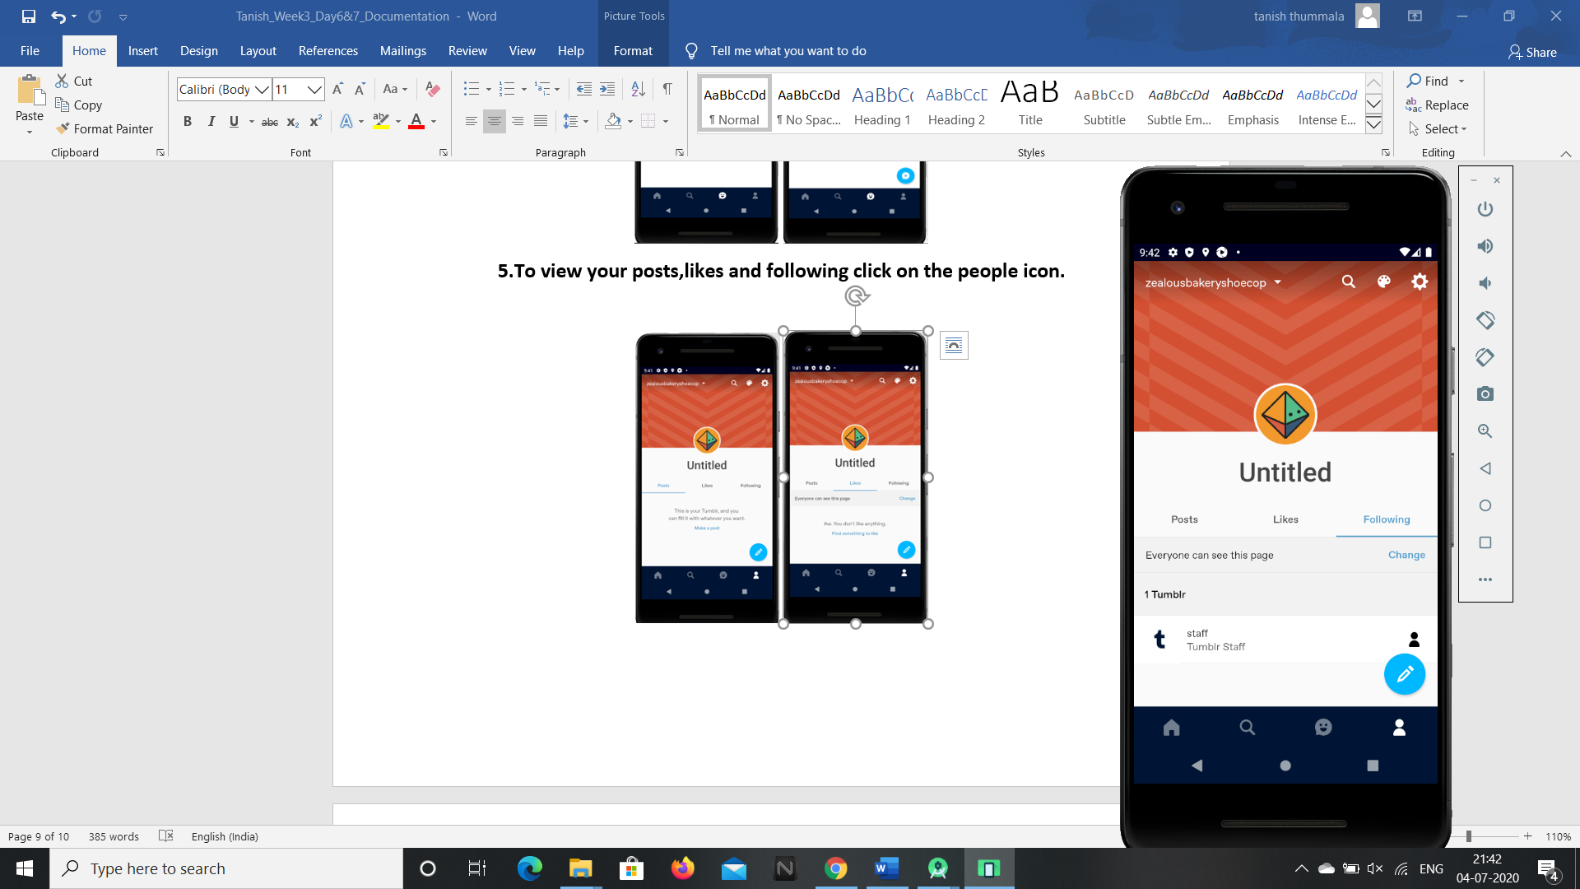

**7.To access group chats click on the chat icon on the top right corner of the home page.**

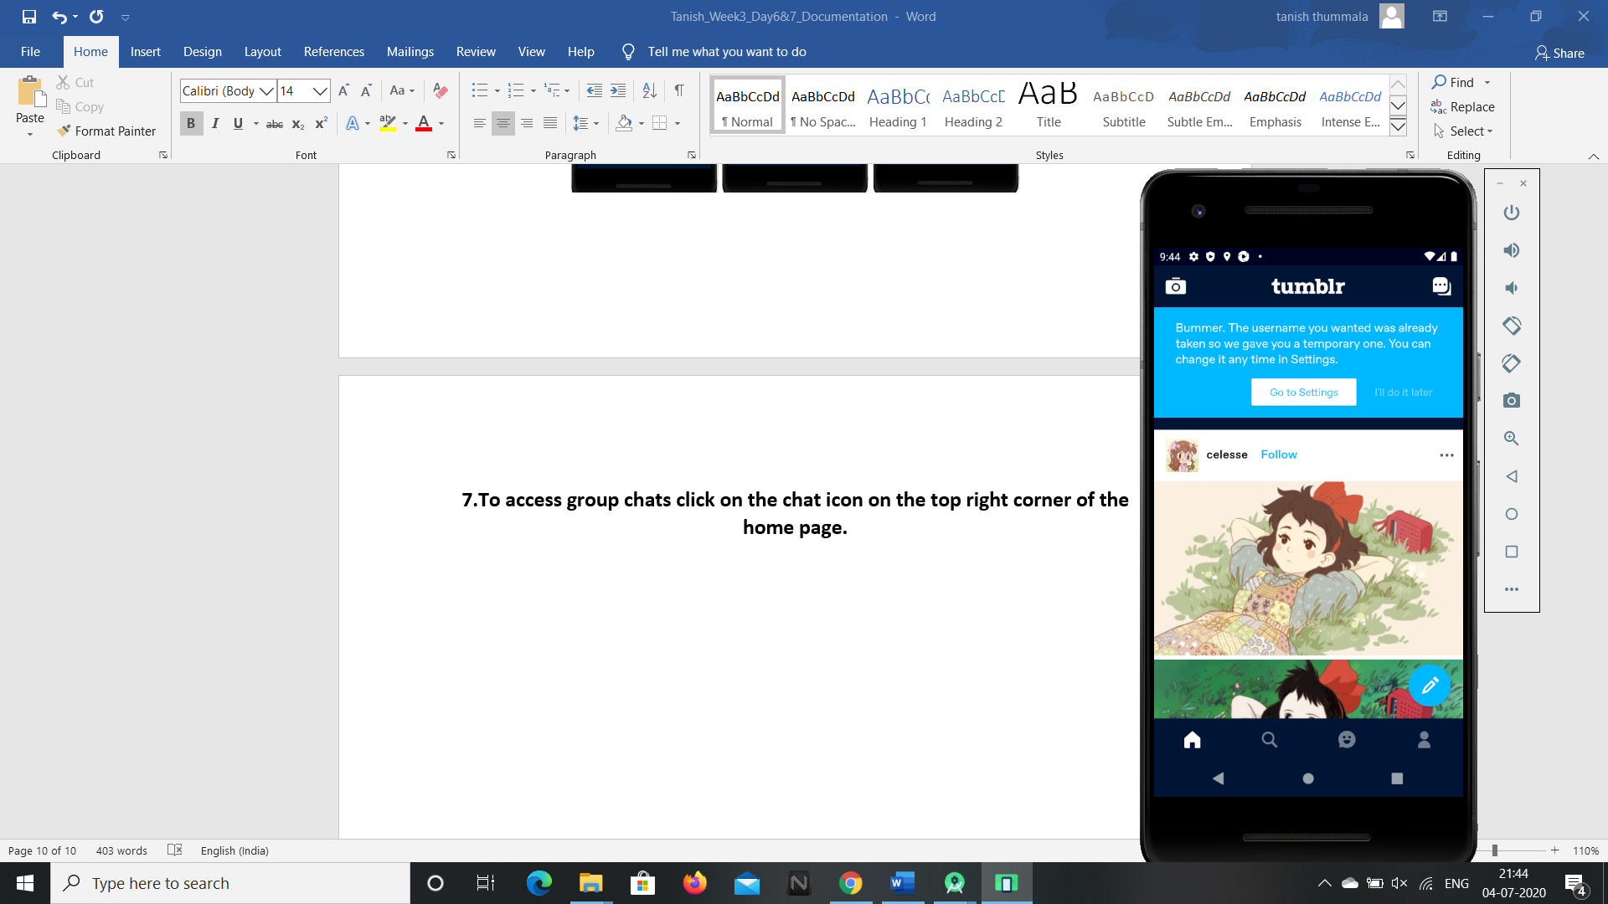 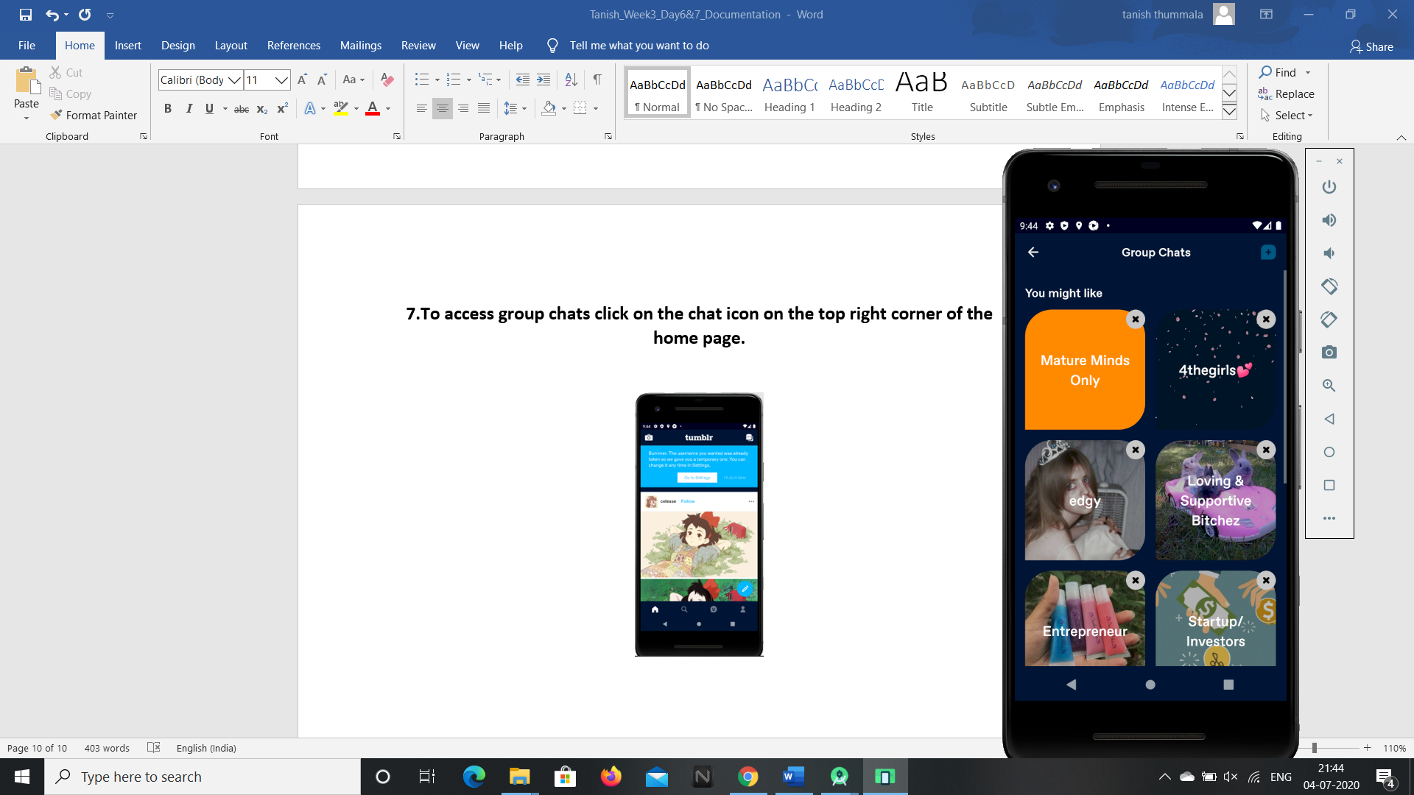

**8.To access camera and microphone to post your blogs click on the camera icon at the left corner of the phone.**

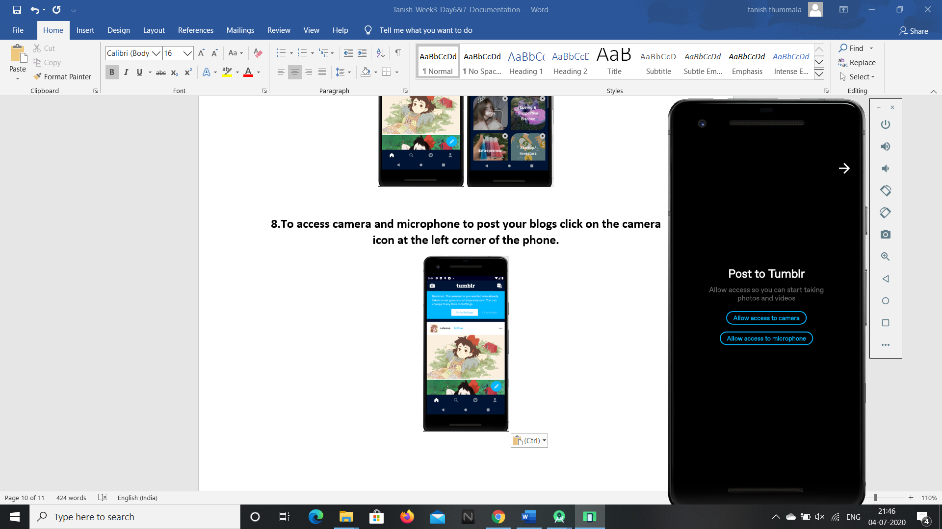

**So these are the features present in the tumblr android application and these can be accessed by G1ANT Robot through Appium addon.**